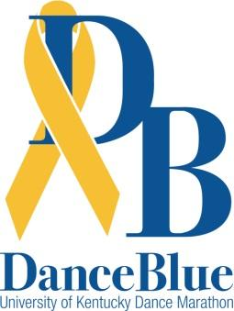
To whom it may concern:
We are the Team Name DanceBlue team. DanceBlue is a University of Kentucky student-run organization that fundraises year-round and culminates in a 24-hour no-sitting, no-sleeping dance marathon. The money that DanceBlue raises is donated to the Golden Matrix Fund, which is established to support the kids and families of the DanceBlue Golisano Children’s at UK Hospital Pediatric Hematology/Oncology Clinic.
To give you a bit of history:
- DanceBlue hosted its first dance marathon in the spring of 2006.
- In 2020, over 100 student groups, representing thousands of UK students, sponsored 923 dancers. We raised over $2 million for the kids!
- Last year, in 2025, we raised over $2.3 million for the kids at our 20th anniversary dance marathon!
- In twenty years, DanceBlue has raised more than $25.3 million, and we won’t stop there!
As the Team Name DanceBlue team, we are looking for companies to help sponsor our 24 hours at the marathon with an income tax-deductible gift for DanceBlue. We would love to partner with your restaurant to host a fundraiser night, where a portion of the proceeds - determined by you - will come to DanceBlue as a donation to the Golden Matrix Funds on behalf of our team. Your gift will directly benefit resilient kids and their families in the DanceBlue Clinic, as well as propel the search for a cure.
Benefits of hosting a restaurant night for a DanceBlue team include but are not limited to:
- Promoting your business among UK students
- Having a potentially higher flux of customers
- Building a relationship with DanceBlue, one of the fastest growing philanthropy events in the SEC
- Making a positive impact on the lives of the children and families at the DanceBlue Clinic
Remember, all gifts to UK DanceBlue are income tax-deductible, and you will receive an official gift receipt from the Philanthropy Office at the University of Kentucky. For more information, feel free to reach out to the Fundraising Chair at fundraising@danceblue.org or visit our website danceblue.org.
Together, we can make this the best year yet, all for the kids!

Sincerely,
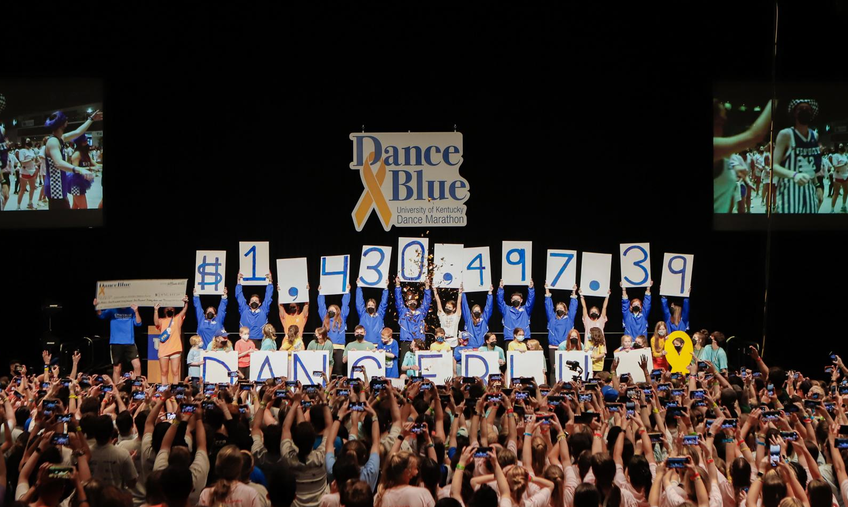
Team Name DanceBlue Team

